RODABE RUDIN PILCM Cert (HE) in Local Policy Studies
3 Wellfield, Lewes Road, Ashurst Wood, West Sussex, RH19 3SX
Tel: 07883 816016 ~ Email: rodaberudin@gmail.com

END OF YEAR

INTERNAL AUDIT SERVICE FOR …Danehill TOWN/PARISH COUNCIL

I certify that I have carried out the tests detailed below in accordance with the suggested approach contained in the 2008 edition of “Governance and Accountability in Local Councils in England and Wales – A Practitioners Guide”. Where an entry has been made in column 4 the supporting Working Papers are attached.

Signed 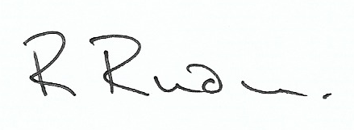 Date 11th April 2019

1  Internal Control | 2  Tests | 3  Yes | 4  W/P  Reference | 5  Comments
Previous Internal Audit Report | Do the minutes record that Council has considered the Internal Audit Report for the previous year and the matters arising addressed? | X
Assets Register | Review for completeness and in light of insurance cover | X
Budgetary Planning | What is the process?  Is progress against budget regularly monitored? | X
Petty Cash | Select a sample of petty cash payments and receipts and agree to supporting documentation, verifying:  - Amounts  - Authorisations  - VAT Analysis | N/A
Insurance | Review insurance cover and ensure all fixed assets are adequately covered | X
 | Has PAYE/NIC been properly operated by the Council as an employer? | X |  | Outsourced
Bank Reconciliation | Is there a bank reconciliation for each bank account? | X
 | Is the bank reconciliation carried out regularly on the receipt of statements? | X
Year-End Procedures | Are year-end accounts prepared on the correct accounting basis? | X
 | Do accounts agree with the cashbook? | X
 | Is there an audit trail from underlying financial records to the accounts? | X
 | Where appropriate, have debtors and creditors been properly recorded? | X

