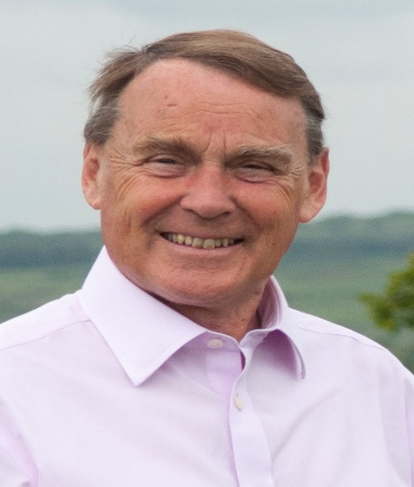

Local Update February 2023

Protect Our Villages.

In recent years , our villages have been under threat from applications for extensive housing development; many of these have not yet been built out. We do, of course, need more homes especially for young people who cannot afford a first home in our expensive area. However, the quantum is excessive.
For the last 14years as a Councillor, I have fought for limited development in our villages. Nutley and Fairwarp have been largely protected because they are so near to Ashdown Forest as have Chelwood Gate and Danehill. Fletching and Piltdown have not seen too much development because they are quite self-contained. Similarly Buxted, High Hurstwood and Isfield have not been too seriously affected. However, Maresfield has seen a lot of change with more to come and Five Ash Down is facing too much housing despite the appeal on the Walled Garden site being dismissed.
We now have a new application, not for housing but for a massive extension to the Ashdown Business Park. This is a 75 acre site with 60000 square metres of commercial buildings being proposed.
In my opinion it means a loss of agricultural land, harm to the landscape, flood risk, power generation problems and a huge increase in traffic on our inadequate roads.
For me, this looks like a turning point. It will be the catalyst for changing our rural environment for ever. We cannot let the Planning officers rush into approving this.
Some, of course, will welcome new jobs but there are better locations and a commercial development is already approved as part of the Ridgewood Development.
I would welcome your views and your support in resisting further development especially of the Ashdown Business Park extension.

Council Tax.
Regrettably our Council Tax will increase by about 5% next year. The County Council, which accounts for 70% of our tax, have agreed a 4.99% rise with 2% of that dedicated to Adult Social Care despite a government grant of £30m. The Fire Authority have agreed a 5% rise. The Police and Crime Commissioner has put up her precept by over 6%. Wealden Council is likely to agree a 3% increase.

Roy Galley

February 9th 2023

Your local Councillors.

Roy Galley. cllr.roy.galley@eastsussex.gov.uk
cllr.roy.galley@wealden.gov.uk
01825 713018

Toby Illingworth. Cllr.toby.illingworth@wealden.gov.uk
07772 864683

