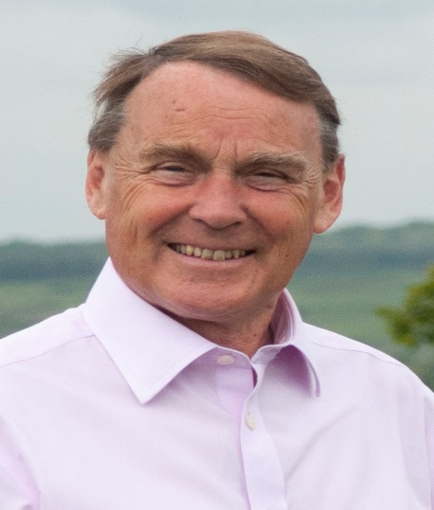

Local Update.

March 2021

Tackling the Climate Emergency in Wealden

It is timely to update everyone on local progress with the Climate Change agenda.Whilst a lot of Council focus has been on the impacts of Covid , business as usual has continued.
Wealden District Council declared a Climate Emergency in July 2019 and we published our first Climate Emergency Plan in December 2019, setting out our net-zero ambitions for the Council and the District.
However, we can’t begin to set ourselves meaningful targets or measure progress until we better understand where we are starting. We therefore began by analysing our own greenhouse gas emissions, as well as that of the wider District, and creating baselines for both. We also modelled the potential impact on future emissions of a range of policy and technological developments. Ultimately, this has enabled us to identify the key intervention measures and steps needed to achieve the decarbonisation target.
It is perhaps easiest to start where we have the most control – our own assets. Almost all of our corporate and retirement living buildings are now powered by renewable energy sources. Solar PV panels are installed at 10 of our retirement living schemes and the Council offices, while air source heat pumps have been installed in our general needs properties. Our main office building has been completely redeveloped to incorporate (amongst other things) passive ventilation, solar shading, solar PV and air source heating, achieving a BREEAM rating of ‘excellent’.
We also have some 3000 Council homes,for which we are developing carbon reduction plans . We are exploring alternative heating options for our off-gas homes, and hydrogen ready and hybrid systems for others. We know that there will not be one single solution for gas replacement, so we are investigating a range of alternatives.
We only have a small vehicle fleet, which we have started to replace with electric vehicles, and we are working with our waste contractor to plan how to decarbonise our waste collection service.
Planning permission was
Perhaps the biggest impact that we can have on emissions, however, is through our ability to influence and facilitate change locally and nationally.
We know that emissions across our District have reduced by over 32% since 2005, but we know this is not enough. As an area, our main challenges are emissions from transport (which equate to 47% of all emissions) and domestic gas and electricity consumption.
One of our current priorities is to install electric vehicle charge points into our car parks throughout the District, to increase the availability of public infrastructure and stimulate the switch to electric vehicles.
Planning permission was recently given for a multi EV charging point and solar farm near Copwood rounabout ,Uckfield. This has understandably caused a lot of concern locally but it will give us a head start with EV Charging infrastructure
Through the planning process, we have so far also granted permissions for one wind farm and nine solar farms, and we have recently delivered a solar PV and battery storage group-buying scheme for residents and businesses. Collectively, we are already producing enough renewable electricity in the District to power around 40% of all our housing.
We are planning the wholesale regeneration of our largest market Town and a whole range of low carbon and ecological features are being incorporated, including low carbon building design, the co-location of technology (such as solar PV, battery storage and EV charge points), and a district heat network.
However, we know we cannot achieve our net-zero ambitions alone; we all need to get involved. Therefore, we are engaging with our local communities, to share information and exchange ideas, including recently through a virtual Climate Day for Town and Parish councils.
Our residents are active and engaged. We have a 51% recycling rate in the District and we are committed to increasing this further through campaigns and education. Of the 49% that is not recycled, 48% goes to a local incinerator, the energy from which is fed into the National Grid.
Some of the initiatives we are supporting include:
- The Solar Together project to enable the uptake of Solar PV and battery storage by property owners (more than 1000 have registered so far).
- A project to accelerate the uptake of renewable technology in an industrial estate.
- The Riding Sunbeams project, which will allow a community-owned solar farm to generate power for railway lines.
- Awareness campaigns to encourage take up of the Green Homes Grant scheme.
- A community project to help residents understand the benefits of switching from oil fired to renewable heating systems
- The Great British Spring Clean campaign, which has extensive community involvement, with over 40 groups regularly taking part and many carrying on litter picking throughout the year.
Of course, the thinking behind the Climate emergency must be embedded in all our future planning, and climate change is one of the key considerations shaping our new Local Plan.

Roy Galley

March 12th 2021.

Your local Councillors.

Roy Galley. cllr.roy.galley@eastsussex.gov.uk
cllr.roy.galley@wealden.gov.uk
01825 713018
Peter Roundell. cllr.peter.roundell@wealden.gov.uk
01825 722030

Toby Illingworth cllr.toby.illingworth @wealden.gov.uk
01823 732115

