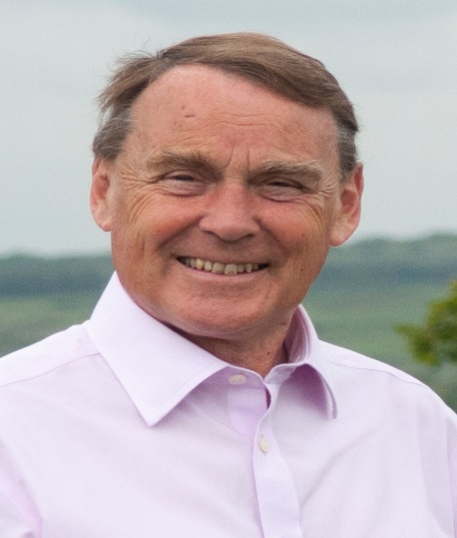

Local Update March 2023

Protect Our Villages

NO NO NO

NO to a Planning Application for an expanded Ashdown Business Park.
This application surfaced publicly in January. It seeks a new Business Park of 77 acres with 52 acres covered by 60000 square metres of Business Units. The figures are difficult to envisage but it is huge.
It will generate a lot of extra traffic over the next 10 years and adversely affect the landscape and overall environment including Ancient Woodland and the Shortbridge stream.
Most importantly it will destroy the Village environment we all treasure so much.
We must work together to resist it.

NO to 2000 houses at Owlsbury Farm.
Only today (March 10th) have I been briefed by the sponsors of a planning application in its very early stages but with an outline plan to build about 2000 houses with a school and a sports park at Owlsbury Farm. This land stretches from Little Horsted to Buckham Hill.

If this comes forward it will ruin rural North Wealden for ever. It will be a carbuncle on the side of Uckfield. We must resist this too.

NO to Major and Random Applications without a proper Local plan.
Applications of this size and impact should only be considered as part of a formal Local Plan on which there must by law be extensive consultation.

NO TO THESE MAD DEVELOPMENTS CONCRETING OVER OUR VILLAGES AND FIELDS.

Roy Galley

March 10th 2023

Your local Councillors.

Roy Galley. cllr.roy.galley@eastsussex.gov.uk
cllr.roy.galley@wealden.gov.uk
01825 713018

Toby Illingworth. Cllr.toby.illingworth@wealden.gov.uk
07772 864683

