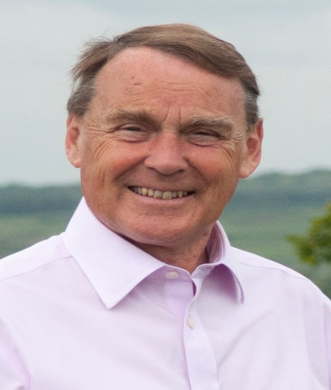

Local Update.

January 2021

Covid

Vaccinations.

From my recent contacts with local GP Practices, they are still awaiting details of vaccine supplies. However the local NHS has today confirmed that 7 practices will soon start vaccinating over 80s and I know some have already had their jab.
The Meads Medical Centre in Uckfield will be one of these seven.
It is expected that a further service will begin at the Saxonbury House Practice in Crowborough.
It is important that, when called for a vaccination, you attend. Some are not in favour of vaccination so please let the NHS know if you will not be taking up your invitation so someone else can take up the appointment.
Please do not ring for an appointment; the system should ensure you are called.

Cases

As of today, cases are spiralling.

The advice is TO STAY AT HOME except for:
- Food shopping
- Going to work if you can’t work at home.
- Exercise once a day locally
- Medical assistance
- Education or childcare for those eligible

The Wealden Community Hub continues working if people have problems with obtaining necessary supplies.

Council Tax.

Debates are ongoing about the level of Council Tax for 2021/22.

The Conservative Group will be recommending that Wealden District Council do not to increase Council Tax at all because so many of our local businesses are struggling and many people face economic difficulties with unemployment or part-time working.
We will not be able to offer a pay increase except for £250 for those earning £24,000 or less in line with the government pay freeze policy for the public sector. There will be no increase in Councillors’ allowances.

Decisions have yet to be made by the County Council, Fire Authority and the Police and Crime Commissioner.

Local Plan.

Consultation on the ‘Direction of Travel” documents closes on January 18th 2021. The documents are available on the Wealden District Council website https://www.wealden.gov.uk/planning-and-building-control/planning-policy/wealden-local-plan-direction-of-travel-consultation
The next consultation will be a draft Local Plan in Spring 2022.

Gillian Bullock

It is with great pleasure that I learnt that Dr Gillian Bullock, a resident of Maresfield well known to many people has receive a BEM in the New Year’s Honours list for her work in founding and running the charity CHADIK – Child Health and Development in Kenya. She has worked tirelessly for disadvantaged children in Kenya aiming to improve their life chances through education and health. This honour is well deserved.

Roy Galley

January 8th 2021.

Your local Councillors.

Roy Galley. cllr.roy.galley@eastsussex.gov.uk
cllr.roy.galley@wealden.gov.uk
01825 713018
Peter Roundell. cllr.peter.roundell@wealden.gov.uk
01825 722030

Toby Illingworth cllr.toby.illingworth @wealden.gov.uk
01823 732115

