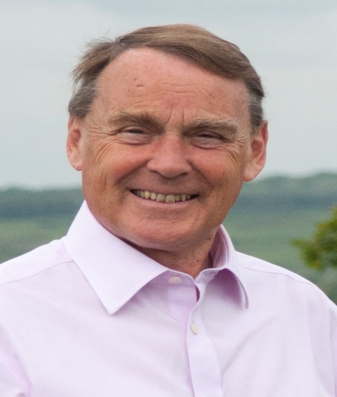

Local Update

Covid 19

The health situation in East Sussex
East Sussex continues to see a comparatively low number of cases of Covid-19. The latest figures show a cumulative rate of 271 cases per 100,000 of population
Table: Total number of lab-confirmed cases of COVID-19 in East Sussex
Area | No. of cases | Rate per 100,000 population
Eastbourne | 393 | 381.0
Hastings | 127 | 136.8
Lewes | 361 | 351.4
Rother | 182 | 190.3
Wealden | 442 | 275.9
East Sussex | 1,505 | 271.4
England | 247,609 | 442.3
Source: https://coronavirus.data.gov.uk , 9 July 2020

Table: Number of COVID-19 deaths recorded in hospitals at Sussex NHS Trusts
NHS Trust | No. of registered deaths
East Sussex Healthcare NHS Trust | 90
Sussex Community NHS Foundation Trust | 18
Brighton & Sussex University Hospital Trust | 146
Source: NHS COVID-19 deaths in hospitals | 9 July 2020

Next Steps

Work is now progressing on an East Sussex Local Outbreak Plan covering Care Homes, Schools, Testing, Tracing, Vulnerable people and other related topics.

Wealden is publishing a Restart and Recovery Plan which aims to –

- Support existing businesses and create the right conditions for businesses to reopen.
- Support employees now unemployed to find new jobs
- Ensure all Council services are fully operational as soon as possible.
- Review and update our emergency planning.
- Scope the future financial challenge.
- Try to embed the positive changes seen in recent weeks from community resilience and volunteering

In Wealden, £38m has now been paid out in Business Grants with an additional £1m from the discretionary Grant scheme. The discretionary scheme still has funds available and applications can be made up to July 27th by small businesses in shared units, market traders, bed and breakfast businesses who pay Council Tax, and Charity properties.
£ 14.7m of Business Rates Relief has been provided to 2,200 businesses.
Leisure Services will be opening soon.

In East Sussex:
- some libraries will be opening from July 13th.
- Wedding services at Registry Offices can go ahead
- There are about 11000 Primary pupils in school and 1500 Secondary pupils.
- Schools will all reopen in September but there are still concerns about space given social distancing.
- More services at Household Waste and Recycling Centres are being opened up.
- A lot of road maintenance is going ahead with work completed at the build out on School Hill, Maresfield and work promised for Ruston Bridge Road, Fletching and School Lane, Danehill.

All this information is up to date on July 10th but we are, of course, in a fast moving situation.

Roy Galley

July 10th 2020.

Your local Councillors.

Roy Galley. cllr.roy.galley@eastsussex.gov.uk
cllr.roy.galley@wealden.gov.uk
01825 713018
Peter Roundell. cllr.peter.roundell@wealden.gov.uk
01825 722030

Toby Illingworth cllr.toby.illingworth @wealden.gov.uk
01823 732115

