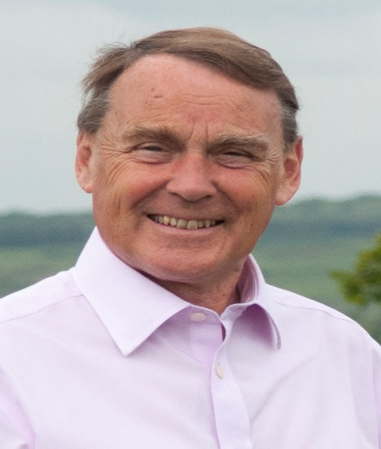

Local Government News. February 2019.

Council Tax

The County Council has approved a council Tax rise of 2.99% which is the highest level allowed without a referendum. The level of cuts in service will be reduced to £5.1m as a result of a series of one off grants from Government of just over £8m. We cannot plan on receiving this amount next year but I am pretty confident some of this will be repeated.

Wealden Council Tax will be decided on February 20th and is likely to be an increase of £5 per year on the middle range Band D with proportionate rises for other bands .This amounts to a 2.7% rise.

The Fire Authority will probably go for a 2.94% rise.

The biggest increase of all is in the police precept. This will go up by £24 a year - £2 per month. This is a swingeing increase but we are promised it will pay for 100 new PCSOs, 50 new PCs and 50 more investigative and specialist staff.
We need to see in return for this extra tax, more police in evidence in our communities and more attention paid to burglaries and anti-social behaviour.

Local Policing

Continuing with policing issues, I have recently met senior police officers along with a number of local residents.
We are all very concerned about the recent outbreak of break-ins and burglaries which have affected the Forest Centre, the Llama Farm and others. Police believe more than one gang are involved and have made some arrests relating to some of the break-ins.
Our police remained committed staying close to local people. They would encourage us all to report suspicious behavior and you can contact them via 101 or wealden@sussex.pnn.police.uk.

Update on Highways Issues.

Buxted

A272 Coopers Green 11-13 February and 21-22. Temporary traffic lights for repairs.
A272 Station Road 21-22 February . Temporary traffic lights for carriageway repairs.
A26 Herons Ghyll 21-26 March Temporary traffic lights for drainage repairs

Fletching

Daleham Lane 11 February to March 22-Road closure for replacement of safety barriers.

Maresfield

High St/London Road – 18-24 February Road Closure for carriageway repairs.

Nutley

High St 13-21 February Temporary traffic lights for drainage work.
Down St . 27-29 March Road Closure for BT Openreach work.

Piltdown

A272 Goldridge Road
5-7 March Temporary traffic lights for carriageway repairs

Roy Galley.
February 7th 2019

Your local Councillors.

Roy Galley. cllr.roy.galley@eastsussex.gov.uk
cllr.roy.galley@wealden.gov.uk
01825 713018
Peter Roundell. cllr.peter.roundell@wealden.gov.uk
01825 722030

Michael Lunn. Cllr.michael.lunn@wealden.gov.uk
07894062727
Toby Illingworth cllr.toby.illingworth@wealden.gov.uk
01825 732115

Francis Whetstone cllr.francis.whetstone@eastsussex.gov.uk
01892 771184
Rowena Moore cllr.rowena.moore@wealden.gov.uk
01342 314402
Peter Holloway cllr.peter.holloway@wealden.gov.uk
01342 824434

