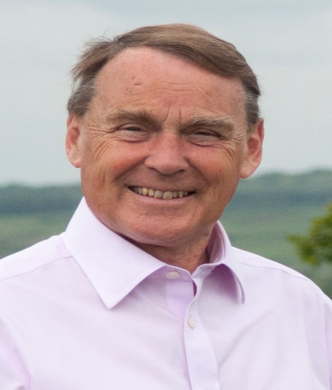

Local Government News. June 2019.

County News

1.Two difficult Consultations are now undewrway.

Community Meals and Working Age Adult services.
What used to be called ‘Meals on Wheels’ has been contracted out by County for some years but the taxpayer has been providing a subsidy.
750 people receive the subsidy at £4.10 per meal. County,frankly, still has to make savings and it is proposing to save £130,000 by removing the subsidy.
The consultation will also look at more focused, less residential based services for working age adults.There is a budget of £50 million with 2500 people receiving longterm care. The proposals will not stop the care but scale it back in less serious cases.

Children and Youth Centres.
We have an extensive network of Children’s Centres and Youth Centres aimed mainly at the 7% of children from difficult backgrounds.
The proposal is to scale this back from 30 Centres to 16 but aiming to preserve 4 specifically Youth Centres.Facilities in Crowborough and Chailey could close but the Uckfield Centre would remain open. Where closures eventually go ahead, County will be looking to volunteer groups to take them on this has worked well for other services.Work with troubled families will continue.

2.Broadband.
A second broadband contract to extend broadband reach has just been concluded successfully. We still have a number of difficult to reach areas and these will be included in Contract 3 currently being negotiated The contractor will be required to survey all the remaining premises before the contract is finalised.
I am seeking assurances that the main hot spots or not spots in our area,for example, Wych Cross, parts of Piltdown and Danehill will be included in Contract 3.

Wealden News.
- The new waste contact will begin on July 1st with Biffa..Kier performance continues to give problems and officers are working daily to sort out the issues in the last month of their contract.
- Under the new contract you will not have to separate glass from other recycling. Technology has moved on and it can now be isolated by machine.
- The charged for garden waste service is going quite well with 22,000 households signed up for it, 80% online. The online booking system seems to have worked well.
- .The first phase of hearings on the local plan have largely finishes with two more days at the end of July.The Inspector will consider her reactions before a Phase 2 begins. We do not expect a decision until the end of the year.It is a long and convoluted process.

Roy Galley

June 6th 2019.

Your local Councillors.

Roy Galley. cllr.roy.galley@eastsussex.gov.uk
cllr.roy.galley@wealden.gov.uk
01825 713018
Peter Roundell. cllr.peter.roundell@wealden.gov.uk
01825 722030

Michael Lunn. Cllr.michael.lunn@wealden.gov.uk
07894062727
Toby Illingworth cllr.toby.illingworth@wealden.gov.uk
01825 732115

Francis Whetstone cllr.francis.whetstone@eastsussex.gov.uk
01892 771184
Rowena Moore cllr.rowena.moore@wealden.gov.uk
01342 314402
Peter Holloway cllr.peter.holloway@wealden.gov.uk
01342 824434

