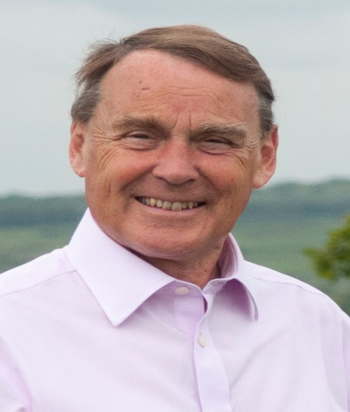

Local Government News. October. 2018.

Parliamentary Boundaries.

As a follow up to last month’s report, The Boundary Commission has now published its final proposals for constituency boundaries.
The Wealden Constituency will disappear and there will be one less constituency overall in East Sussex.
Lewes will combine with Uckfield and become the new constituency of Lewes and West Wealden.
Danehill, Chelwood Gate, Fletching,Piltdown,Nutley, Isfield, Little Horsted will all be in this constituency.
A new constituency of Tunbridge Wells and Crowborough will be formed and Buxted, Maresfield, High Hurstwood and Fairwarp will be included in this along with Tunbridge Wells and Crowborough.

The Government cannot now amend these proposals. Parliament must accept or reject them.
If accepted, they will be the boundaries at the next General Election.

County Council.

The main focus at present is designing what is being called County’s ‘Core Offer’.
These are the statutory services County must provide along with those it is considered essential to offer.
We will then match the resources to this Core Offer.
I think this is a better approach than saying ‘Oh we have a problem.Let’s save a million here and a million there.‘ This is a much more considered approach.

The other important news is that our Children’s Services have been given an OUTSTANDING rating by its inspecting body, OFSTED. Children’s services include adoption and fostering as well as social services for vulnerable children.

Highways.

Bell Lane, Nutley will be closed for drainage repairs from October 22 to 26.
There will be footway surfacing on parts of the Uckfield Bypass from October 23 to 25.
Down St, Nutley, closure for BT works 29 October to 1st November.
Kiln Lane, Isfield, closure for BT cable laying. November 27 to 29
Pound Green,Buxted,and Howbourne Lane, temporary traffic lights for BT work. November 21 to 23

Wealden.

Waste collections continue to be a problem with our contractor,Kier, letting us down badly. Missed bins in August totalled 2790. The aim is no more than about 150 per week. In September, the final figure could well be worse.
I have authorized officers to bring in other contractors where Kier is failing.This is not straightforward but I am determined we must crack this big problem.

Roy Galley.

October 4th 2018

Your local Councillors.

Roy Galley. cllr.roy.galley@eastsussex.gov.uk
cllr.roy.galley@wealden.gov.uk
01825 713018
Peter Roundell. cllr.peter.roundell@wealden.gov.uk
01825 722030

Michael Lunn. Cllr.michael.lunn@wealden.gov.uk
07894062727
Toby Illingworth cllr.toby.illingworth@wealden.gov.uk
01825 732115

