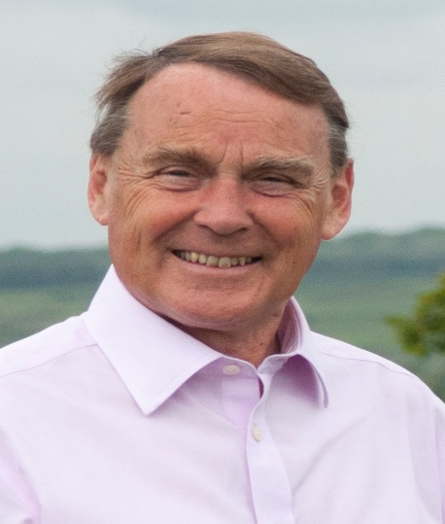

Local Government News. January 2019.

Waste Collection.

Everyone may know by now that the new waste contractor from July 2019 will be Biffa.
They won the contract against stiff opposition and I am optimistic that they will be more competent than Kier.

The Big Spring Clean.
Wealden Council will again be supporting the national Spring Clean campaign.
We are looking for local volunteers to pick up litter throughout our area. Piltdown and Buxted residents do a magnificent job each year and hopefully others will join them in 2019. Wealden will provide all necessary equipment on request.

Gatwick Airport.

The Airport is currently consulting on options for future efficiency and expansion.
The Second Runway option is in the long grass in view of the government’s decision to support a second runway at Heathrow.
However they are consulting on options to-
- Use technical measures to increase capacity to about 60 million passengers per year.
- Bring into operation the standby runway which already exists but is not currently used. This will involve some new infrastructure and increase capacity to 70 million.

Wealden Council has responded to say we could live with either option but for environmental reasons would prefer the smaller scheme.

Tourism.
A recent report on Tourism giving the final figures for 2017 shows that-

£342.6million was spent in Wealden as a result of tourism.
There were six million trips mainly day trips.
7182 jobs were supported by visitor activity with 1186 non-tourism-related jobs supported
17.4% of our employed population were in tourism jobs.

We continue to look for ways to help the tourist industry and hope to sustain recent progress.

Roy Galley.
January 10th 2019

Your local Councillors.

Roy Galley. cllr.roy.galley@eastsussex.gov.uk
cllr.roy.galley@wealden.gov.uk
01825 713018
Peter Roundell. cllr.peter.roundell@wealden.gov.uk
01825 722030

Michael Lunn. Cllr.michael.lunn@wealden.gov.uk
07894062727
Toby Illingworth cllr.toby.illingworth@wealden.gov.uk
01825 732115

Francis Whetstone cllr.francis.whetstone@eastsussex.gov.uk
01892 771184
Rowena Moore cllr.rowena.moore@wealden.gov.uk
01342 314402
Peter Holloway cllr.peter.holloway@wealden.gov.uk
01342 824434

