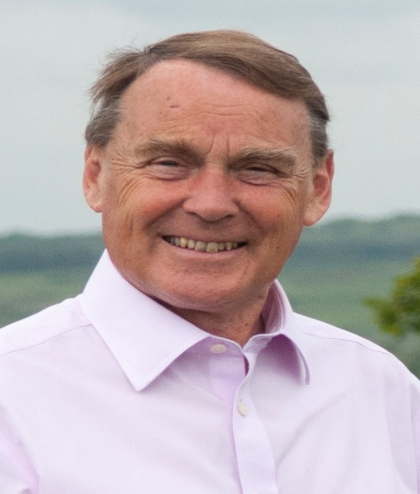

Local Government News. January 2020.

The Local Plan.

As most of you will now know from local media, the Wealden Local Plan has been well and truly rejected by the Planning Inspector.

All councils have a duty to cooperate with neighbouring councils so that if one area genuinely cannot provide the houses needed and its neighbour has spare land, then the land rich council should consider taking extra houses. In Wealden we have a lot of land and a lot of unspoilt greenery which is one of the reasons we all like to live here. Some of our neighbours ,especially Eastbourne, are not as fortunate. We were severely criticised by the Inspector for not being more helpful. Wealden that took an arguably rational view that if Eastbourne did not have much spare land, they could build upwards with more high rise blocks. The Inspector was not impressed.

Then there was the issue of Ashdown Forest. We have always sought to protect the Forest,its rare habitats and wildlife. The Inspector did not suggest this was entirely wrong but the methodology we used to measure impacts on the Forest was the most extreme approach and the inspector said it was not rational, especially that Wealden did not factor in the likelihood of more low emission vehicles in the next few years.

The upshot is that we have to start again on a new Local Plan. The only alternative would be to appeal and fight the Inspector. The terms of her letter are such that it is clear that is a battle Wealden Council could not win.

If we do not have a Local Plan, then it is more difficult to stop housing and business developments the Council does not like. The results of this will make some people happy and some very unhappy. The certainty is that we will have to grant more permissions for bigger developments. Whether they are all built will depend on whether builders think they can sell them. They won’t build unless they are sure there is a market for their houses.

More details on the impact of all this will emerge in the coming weeks and I will keep you updated.

Roy Galley.

January 10, 2020

Your local Councillors.

Roy Galley. cllr.roy.galley@eastsussex.gov.uk
cllr.roy.galley@wealden.gov.uk
01825 713018
Peter Roundell. cllr.peter.roundell@wealden.gov.uk
01825 722030

Toby Illingworth cllr.toby.illingworth@wealden.gov.uk
01825 732115

Francis Whetstone cllr.francis.whetstone@eastsussex.gov.uk
01892 771184

