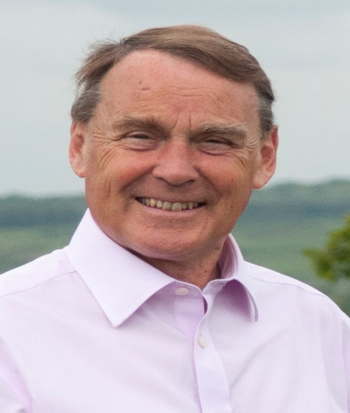

Local Government News.November.2019.

Tourism

We have recently received a report from Tourism South –East about the Economic impact of Tourism in Wealden for 2018. It takes a while,of course, to collect the data.

This shows our visitor economy continues to thrive.
The estimated overnight stays in Wealden were over half a million giving a 6% increase on last year. A quarter of these trips were by overseas visitors and the time spent here by them increased.
Nearly 5.5 million day trips were made .Total spend by all visitors was over £310 million, an increase of 8 %.
The estimated number of jobs supported was 9,700, a rise of over 7%.

Other businesses are also thriving with new activity in building on our industrial estates and new businesses are being created. The wine growing sector is a significant growth area.

So what about the Environment?

We want our economy to prosper and we have to build new houses so how can we square all this with looking after our environment.

We are working on our plan to react effectively to Climate change with a target to reach net –zero CO2 emissions by 2050.
We are establishing the baselines for our emissions and looking at sensible measures to reduce those for the Council operations and the District as a whole.

For Council properties,emissions from gas heating make up the largest proportion,followed by electricity use.
For the District, the biggest effect is transport with domestic emissions a close second. (Not Surprisingly!)

So we need to look more at the energy efficiency of Council buildings although we have done a lot of work already.
We will be looking to put in appropriate Electric Vehicle charging points across the District and looking at options for other low emission vehicles.
We should also be looking at the scope for yet more trees and biodiversity.
We will be relying on national policies particularly the ‘Decarbonisation of the National Grid’ where the aim is no electricity derived from fossil fuel.

There again, there are issues about emerging new technology, how do we deal with battery storage and disposal to name a few.

Exciting times ahead.

Happy Christmas and New Year to all.

Roy Galley

November 5th 2019.

Your local Councillors.

Roy Galley. cllr.roy.galley@eastsussex.gov.uk
cllr.roy.galley@wealden.gov.uk
01825 713018
Peter Roundell. cllr.peter.roundell@wealden.gov.uk
01825 722030

Toby Illingworth cllr.toby.illingworth@wealden.gov.uk
01825 732115

Francis Whetstone cllr.francis.whetstone@eastsussex.gov.uk
01892 771184

