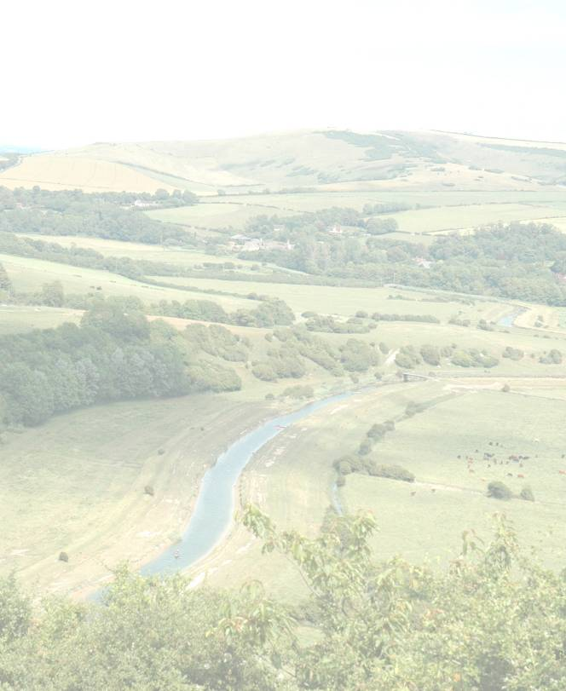

HOUSE TO RENT

in

OAKTREE COTTAGES

a two bedroom house

To apply you must be on the Council's housing register.
To join the register go to www.sussexhomemove.org.uk
or call 01323 443380 and ask for a housing application form.

Preference will be given to applicants with a local connection to Danehill, then applicants with a local connection to an adjoining parish, then applicants from the District.

Bidding opens on Thursday 15th November and closes on Wednesday 21st November

Bid online at www.homemove.org.uk

