Summer 2022

Your Parish Danehill Parish Council Newsletter

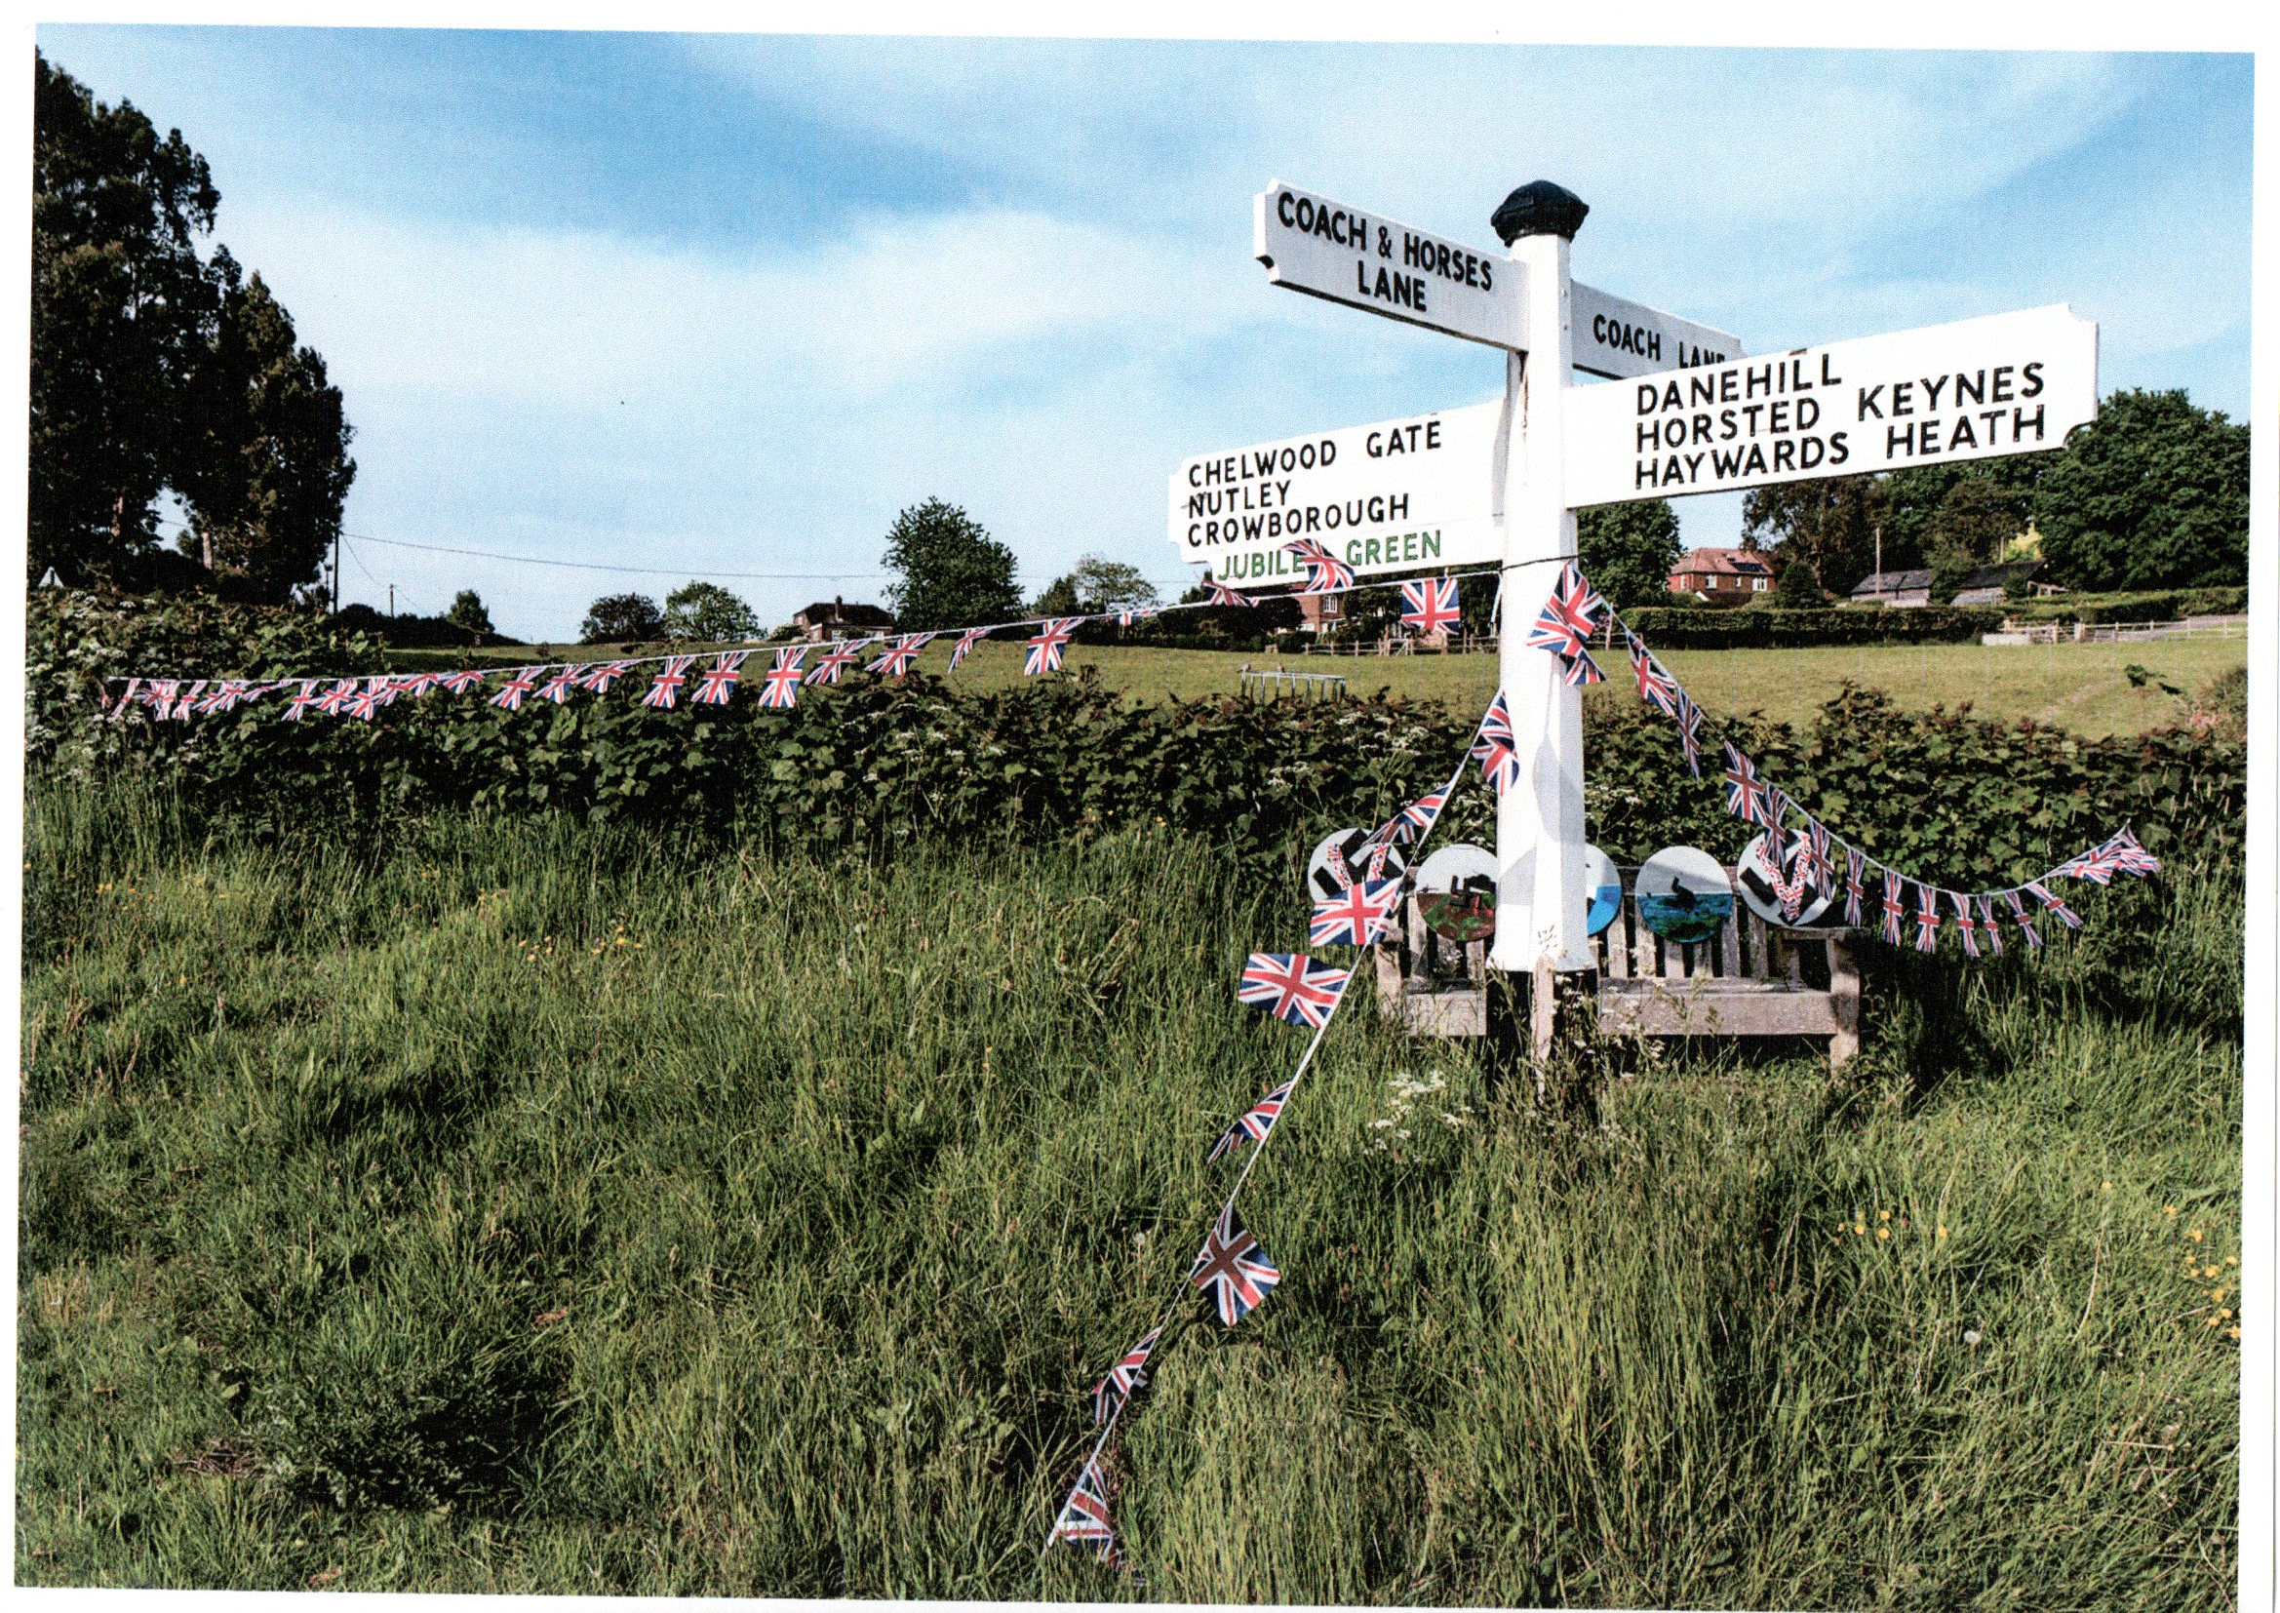

Platinum Jubilee Edition

Millennium Footpath Group

A small group of volunteer parishioners look forward to Monday mornings when they walk the footpaths and bridleways of the parish. Their aim is to ensure that paths, styles and bridges are clear and in good condition for everyone to use.

However they are not always aware that a fault exists and rely on feedback from walkers and riders about any problem with these rights of way.

Locations of problems are not always clear but there is a website that can pin point the area of concern if you go to [www.eastasussex.gov.uk/rightsofway,](http://www.eastasussex.gov.uk/rightsofway,) select online ROW , map, and view ROW.map view map full screen ,add place name(Danehill)and find scroll to enlarge this will give you footpaths highlighted. From the key listed and clicking on path you can identify the path number style or bridge.

Using this map will help to identify accurately and report any problem for a swift rectification.

The local contacts are Mike 01825 740585 or [clerk@danehill-pc.org](mailto:clerk@danehill-pc.org)

IF YOU HAVE FEW HOURS FREE ON MONDAYS AND WANT TO VOLUNTEER TO JOIN THIS GROUP PLEASE CONTACT ALSO [robin@danehill-pc.org](mailto:robin@danehill-pc.org)

**IN THIS ISSUE**

COUNCIL PUBLIC MEETING CALENDAR

Jul 13 th Danehill Memorial Hall

Sep 14 th Chelwood Gate Village Hall

Oct 19 th Danehill Memorial Hall

Nov 16th Chelwood Gate Village Hall

Calendar 1

Contacts 3

Jubilee 2

Post Offices 3

Parish Activities 1 4

**G**

Queen’s Platinum Jubilee

**CHILDREN’S PARTY 3—5PM MARQUEE DANEHILL RECREATION GROUND**

Thur Music & games with children’s songwriter& performer AL START

2ND

JUNE £5 per child purchase tickets from www.ashdown-weekend.com

**PARTY IN THE PARK – FREE- DANEHILL RECREATION GROUND**

Club @Danehill Bar. During the evening at 9.45pm, we will take part in the nationwide beacon lighting with our own light show illuminating the rec.

**ART EXHIBITION 11AM—5PM- FREE- DANEHILL RECREATION GROUND**

Fri Art celebrating the Queens reign & history of the parish

3RD **AFTERNOON TEA 3-5PMDANEHILL MEMORIAL HALL**

JUNE Please contact us if you wish to attend 01825 740678

SAT4TH **OUNTRY FETE 12-4PM DANEHILL RECREATION GROUND**  JUNE Craft & Produce stalls, Brass Band ,Games & rides , bell Ringers,

Miniature Railway, Pony Rides, Café, Slick Mick’s BBQ, Club@Danehill Bar

**JAZZ DUKES 6PM-FREE-MARQUEE DANEHILL RECREATION GROUND**

Live jazz performance

SUN **PLATINUM CELEBRATION 11AM ALL SAINTS CHURCH DANEHILL**

5TH **PARADE 12 PM**

JUNE From the church to Danehill recreation ground join the festival feel with flags for you to wave

**JUBILEE PICNIC LUNCH 12.30 PM MARQUEE DANEHILL RECREATION GROUND**

**Councillors**  **Responsibilities**

Planning, Finance,

Rhodri Lewis. Chairman [rhodri@danehill-pc.org](mailto:rhodri@danehill-pc.org) Recreation Ground, Jubilee Green,

Nigel Hogg [nigel@danehill-pc.org](mailto:nigel@danehill-pc.org) Chairman of Finance,

Chelwood Gate Green,

Tony Blake [tony@danehill-pc.org](mailto:tony@danehill-pc.org) Chairman of Planning, Finance,

Wealdlink, Trees,

Tony Martin [tonym@danehill-pc.org](mailto:tonym@danehill-pc.org) Emergency Planning, Finance,

Planning , Finance, Rights of Way,

Robin Wood [robin@danehill-pc.org](mailto:robin@danehill-pc.org) Communications, Chelwood Gate Village Hall, Planning, Finance,

Katherine Allenby [Katherine@danehill-pc.org](mailto:Katherine@danehill-pc.org) Ashdown Weekend Liaison,

Joan Stott [joan@danehill-pc.org](mailto:joan@danehill-pc.org) Trees, Planning, Finance,

f

ure

Danehill Parish

Council Office

Services are available every Friday at

Chelwood Gate Village Hall

11.30am to 1.0pm



Club@Danehill

1.30pm t0 4pm  Club @ Danehill

1.30pm to4 pm

Chelwood Gate Village Hall

Beaconsfield Road

Chelwood Gate

East Sussex RH17 7LF

Emma Fulham

Parish Clerk & RFO

[clerk@danehill-pc.org](mailto:clerk@danehill-pc.org)

[www.danehill-pc.org](http://www.danehill-pc.org)

Tel; 01342 822404

WEALDLINK PASSENGER SERVICE

01892 771332

PASH BOOKINGS

Chelwood Gate Village Hall Danehill Memorial Hall

01825 740181 01825 790797

Club @Danehill

01825 791725 01825 790484

Recreation Grounds Ashdown Forest Health Centre

01342 822404 01342 822131

Tree Planting

In the autumn of 2021 the parish council was instrumental in organizing and planting 495 plus trees on the Danehill recreation ground on a large open area of ground with the idea of assisting in the draining the area below this. Trees were also planted around the play area and the tennis courts to act as windbreaks, in addition a number of trees were planted on the slope between the A275 and the cemetery to ensure stability of this slope.

E-forests supplied the trees free of charge to the parish and supervised the volunteers who planted these which consisted of a large variety (36) of different species including yew, wild cherry, hawthorn and hazel.

When established this should certainly add to the attractiveness of the rec. and the approach to Danehill,

Parking on Curb’s and Pavements

Please can you help us make walking around the villages of our parish safer for pedestrians by trying to ensure that your visitors , delivery drivers and tradesmen do not park on the pavements

Obstructing the pavement is a danger to those with limited mobility and disabilities, families with children as it forces them out onto our busy roads

It also causes avoidable damage to curbs and pavement surface which is very noticeable throughout the parish.

Hopefully a polite request to drivers be sufficient and help keep our pavements clear whenever possible

The Club @Danehill

This important facility in the Village has recently undergone major refurbishment and is now very welcoming and the Club looks forward to welcoming new members.

Its history dates back to 1886 when M r H C Hardy started it off as a Working Men’s Club and Reading Room, but perhaps its greatest heyday was as the British Legion Club just after World War ii where ex servicemen could go and meet like-minded compatriots.

But times change and because of restrictions, as to who could be allowed into the Club, Laurence Hardy Bun. Ba*ke*rand Shon Bennett campaigned successfully to permit access to everyone – including women – and made the Club inclusive to all. This meant a major revamping of the rules.

The Club has continued to be innovative and has changed with the time..It has a strong family ethos and

looks forward to welcoming all from our community.GR

TheClub@Danehill2022

2022 has got off to a flying start for the Club Membership renewals have been positive, with some new members and grant funding have meant we can now start putting refurbish plans into action

A huge thank you to Danehill Parish Council for their support in helping us improve our community facility.

Fed- up with Anti-social Driving? Report it online at [www.operation](http://www.operation)crackdown.org it takes 5-10 minutes to complete form and is anonymous